Chapter 11, Problem 20.

The load resistance R_{L} in Fig. 11.51 is adjusted until it absorbs the maximum average power. Calculate the value of R_{L} and the maximum average power.
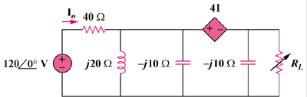

165∠0˚ V

4I_{o}

I_{o}

Figure 11.51
For Prob. 11.20.

